**YEAR 11 HUMAN BIOLOGY**

2010

INTERNAL TRANSPORT TEST 2A

**SECTION A: MULTIPLE CHOICE – 25 MARKS**

**SECTION B: TERMINOLOGY – 10 MARKS**

**SECTION C: SHORT ANSWER – 40 MARKS**

* Answer all questions on the written section.
* No calculators will be allowed.
* Check your answers carefully.
* **Good LuckSECTION A – MULTIPLE CHOICE (25 Marks)**

1. The left ventricular wall is thicker than the right ventricular wall. The difference in thickness of the muscular wall suggests that
   1. The rate of blood flow in the left ventricle is higher than the right ventricle.
   2. More blood is stored in the left ventricle than the right one.
   3. The function performed by the left ventricle is more important than that by the right ventricle.
   4. The left ventricle produces a stronger force in pumping blood than the right ventricle.
2. Pressing the thumb on the wrist of the left hand, one will feel a pulse. This pulse is produced because
   1. The wall of the arteries is thicker than that of the veins.
   2. The arteries carry oxygenated blood.
   3. The blood pumped out of the heart is under high pressure so it travels along the arteries in spurts.
   4. The veins have larger lumen than the arteries.
3. The blood cells responsible for oxygen transport are:
   1. Leucocytes.
   2. Platelets.
   3. Erythrocytes.
   4. Granulocytes.
4. The vessel which carries deoxygenated blood to the lungs is called the:
   1. Pulmonary Vein.
   2. Femoral Artery.
   3. Pulmonary Artery.
   4. Vena Cava.
5. The oxygenated, red carrier pigment in red blood cells is called:
   1. Haemoglobin.
   2. Erythroglobin.
   3. Carbaminohaemoglobin.
   4. Oxyhaemoglobin.
6. After vigorous muscle activity the blood entering and leaving the muscles of the leg of a man are analysed. Which of the following results are most likely to be correct?

|  |  |  |  |  |  |  |  |  |  |  |
| --- | --- | --- | --- | --- | --- | --- | --- | --- | --- | --- |
|  | **BLOOD ENTERING** | | | | | **BLOOD LEAVING** | | | | |
| **Pressure** | **Glucose** | **Oxygen** | **Carbon Dioxide** | **Wastes** | **Pressure** | **Glucose** | **Oxygen** | **Carbon Dioxide** | **Wastes** |
| (a) | Higher | More | More | Less | Less | Lower | Less | Less | More | More |
| (b) | Higher | Same | More | More | Less | Lower | Same | Less | Less | More |
| (c) | Lower | More | Same | Less | More | Higher | Less | Same | More | Less |
| (d) | Same | Less | More | Less | More | Same | More | Less | More | Less |

1. Structures which prevent backflow of blood from the arteries to the ventricles are the:
   1. Atrioventicular valves.
   2. Mitral valve.
   3. Tricuspid valve.
   4. Semilunar valves.
2. Haemoglobin molecules in the red blood corpuscles have a greater affinity for carbon monoxide than for oxygen. People may die of carbon monoxide poisoning after exposure to car exhaust fumes because:
   1. The carbon dioxide carrying capacity of the blood is increased.
   2. The carbon monoxide carrying capacity of the blood is increased.
   3. The oxygen carrying capacity of the blood is increased.
   4. The oxygen carrying capacity of the blood is decreased.
3. As the blood makes a complete circuit of the human body, it travels through the heart;
   1. One time.
   2. Two times.
   3. Three times.
   4. Four times.
4. Which of the following best describes a vein?
   1. Large lumen, thick muscular layer, elastic, no valves.
   2. Small lumen, thick muscular layer, inelastic, valves.
   3. Small lumen, no muscular layer, inelastic, no valves.
   4. Large lumen, thin muscular layer, inelastic, valves.
5. Which term describes a sharp pain in the chest, often during physical activity, which subsides when the person rests?
   1. Angina.
   2. Coronary.
   3. Myocardial Infarction.
   4. Vasoconstriction.
6. The diastolic and systolic blood pressures respectively for a healthy young adult should be:
   1. 65, 150 mm of Mercury.
   2. 120, 80 mm of Mercury.
   3. 70, 115 mm of Mercury.
   4. 115, 45 mm of Mercury.
7. Which one of the following gives a correct path of blood when flowing around the body?
   1. Left ventricle, left atrium, lungs, right ventricle, right atrium, tissues.
   2. Left ventricle, tissues, lungs, right atrium, right ventricle, left atrium.
   3. Left ventricle, lungs, right atrium, right ventricle, tissues, left atrium.
   4. Left ventricle, tissues, right atrium, right ventricle, lungs, left atrium.
8. Coronary arteries provide a blood supply to which of the following organs?
   1. Intestine.
   2. Brain.
   3. Heart.
   4. Pancreas.
9. In which of the following blood vessels would the lowest concentration of Oxyen be found?
   1. Aorta.
   2. Renal artery.
   3. Pulmonary vein.
   4. Pulmonary artery
10. The phase during which the ventricles relax is called:
    1. Systole.
    2. Diastole.
    3. Contraction phase.
    4. Cardiac phase.
11. The protein rich fluid which suspends blood cells is called:
    1. Interstitial fluid
    2. Serum
    3. Intracellular fluid
    4. Plasma

Questions 18 – 19 refer to the following information and to the graph shown below.

1. At which age is the average resting heart rate higher for boys than for girls?
   1. 2 years.
   2. 4 years.
   3. 6 years.
   4. 16 years.
2. If boys of fourteen have an average stroke volume of 75cm3, the volume of blood pumped into the aorta each minute will be closest to
   1. 140 cm3
   2. 1500cm3
   3. 4875cm3
   4. 7500cm3
3. When measuring blood pressure with a sphygmomanometer, no pulse is felt when:
   1. the cuff applies a pressure greater than atrial diastole.
   2. the cuff applies a pressure less than ventricle systole.
   3. the cuff applies a pressure greater than ventricle systole.
   4. the cuff applies a pressure between atrial and ventricle systole.
4. Erythrocytes are unable to divide as they:
   1. are biconcave discs.
   2. would then be only half the normal size.
   3. would have insufficient iron to function efficiently.
   4. have no nucleus.
5. The heart beat is initiated by the sino-atrial node (pacemaker) situated in the;
   1. Right atrium.
   2. Left atrium.
   3. Right Ventricle.
   4. Aorta.
6. Blood pressure at the time of filling the ventricles is called
   1. Systemic.
   2. Diastolic.
   3. Hypertension.
   4. Systolic
7. The heart is surrounded by a double walled layer of epithelium tissue called
   1. Arteriole.
   2. Endocardium.
   3. Periosteum.
   4. Pericardium.
8. When the atrioventicular valves in the heart are closed, blood is prevented from passing from the
   1. Atria to the ventricles.
   2. Ventricles to the atria.
   3. Atria to the arteries.
   4. Arteries to the ventricles.

**END OF SECTION A**

**NAME: __________________________**

**YEAR 11 HUMAN BIOLOGY**

INTERNAL TRANSPORT TEST

*WRITTEN SECTION*

**SECTION A: MULTIPLE CHOICE – 25 MARKS**

**SECTION B: TERMINOLOGY – 10 MARKS**

**SECTION C: SHORT ANSWER – 40 MARKS**

* Answer all questions on the written section.
* No calculators will be allowed.
* Check your answers carefully.

**Good Luck Multiple Choice Answer Sheet**

Put a cross (**X**) next to the correct alternative.

|  |  |  |  |  |  |  |  |  |  |  |
| --- | --- | --- | --- | --- | --- | --- | --- | --- | --- | --- |
| **1** | A | B | C | D |  | **16** | A | B | C | D |
| **2** | A | B | C | D | **17** | A | B | C | D |
| **3** | A | B | C | D | **18** | A | B | C | D |
| **4** | A | B | C | D | **19** | A | B | C | D |
| **5** | A | B | C | D | **20** | A | B | C | D |
| **6** | A | B | C | D | **21** | A | B | C | D |
| **7** | A | B | C | D | **22** | A | B | C | D |
| **8** | A | B | C | D | **23** | A | B | C | D |
| **9** | A | B | C | D | **24** | A | B | C | D |
| **10** | A | B | C | D | **25** | A | B | C | D |
| **11** | A | B | C | D |  |  |  |  |  |
| **12** | A | B | C | D |  |  |  |  |  |
| **13** | A | B | C | D |  |  |  |  |  |
| **14** | A | B | C | D |  |  |  |  |  |
| **15** | A | B | C | D |  |  |  |  |  |

**SECTION B – TERMINOLOGY (10 Marks)**

Give the correct biological term for each of the following.

1. Valves at the base of the aortic arch.

____________________________________________________________________________

2. Blood vessels across which diffusion occurs.

____________________________________________________________________________

3. The major artery carrying deoxygenated blood.

____________________________________________________________________________

4. The condition associated with elevated diastolic and systolic pressures.

____________________________________________________________________________

5. The shape of an erythrocyte.

____________________________________________________________________________

6. Measured by: Heart rate (beats/minute) times Stroke volume (mL).

____________________________________________________________________________

7. The contracting of a blood vessel to reduce blood flow to an organ.

____________________________________________________________________________

8. A condition which occurs when blood flow to part of the heart is stopped completely.

____________________________________________________________________________

9. If blood supply to the cerebral arteries is interrupted this may occur.

____________________________________________________________________________

10. The volume of blood forced from a ventricle of the heart with each contraction.

____________________________________________________________________________

**SECTION C – SHORT ANSWERS (40 Marks)**

1. (8 marks) Name the following structures of the heart.

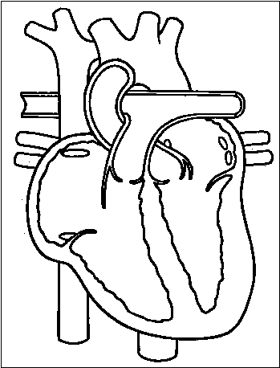

**E**

**A**

**D**

**G**

**F**

**H**

**C**

**B**

A: ____________________________________

B: ____________________________________

C: ____________________________________

D: ____________________________________

E: ____________________________________

F: ____________________________________

G: ____________________________________

H: ____________________________________

1. (6 marks) Study the diagram below.

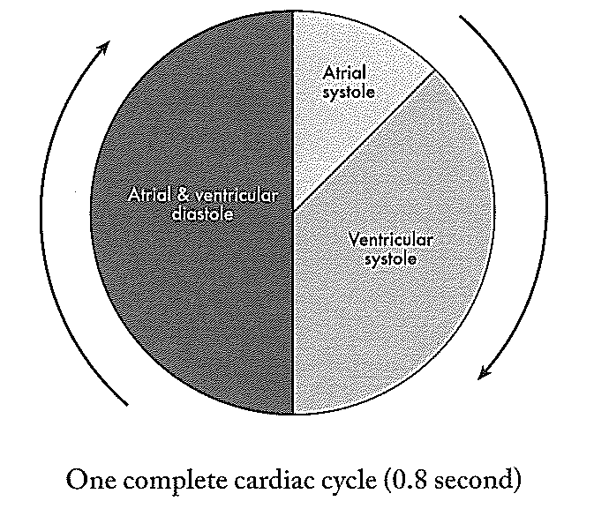

1. What is atrial systole? ________________________________________

________________________________________________________________ [1]

1. What is ventricular diastole? _______________________________________

________________________________________________________________ [1]

1. How long does ventricular diastole last? ________________________________ [1]
2. How long does the atrial systole last? _______________________________ [1]
3. While the ventricles are in a state of diastole, why does the blood pressure remain high in the arteries?

___________________________________________________________________

___________________________________________________________________

______________________________________________________________________________________________________________________________________________________________________________________________________ [2]

1. (5 marks)

At rest or during exercise the various cells of the body have different demands for oxygen and nutrients, both of which are supplied by the blood. Explain how blood flow is regulated by the body to provide a constant supply of blood to the various cells.

________________________________________________________________________________________________________________________________________________________________________________________________________________________________________________________________________________________________________________________________________________________________________________________________________________________________________________________________________________________________________________________________________________________________________________________________________________________________________________________________________________________________________________________________________________________________________________________________________________________

1. (8 marks)

Refer to the figure below which shows a diagrammatic representation of blood pressure in the circulatory system of a mammal. Use the information given in the diagram to answer the following questions.

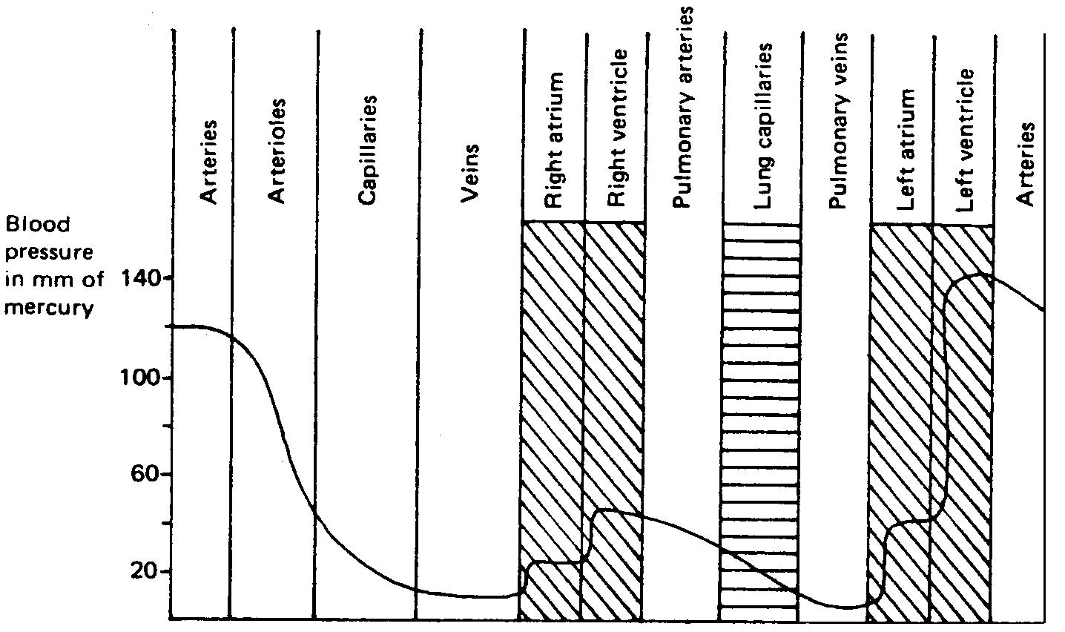

* 1. In which regions of the circulatory system is the pressure the lowest? ____________________________________________________________________ [1]
  2. In which regions is the pressure the greatest? ____________________________________________________________________ [1]
  3. Calculate how many times the pressure in the left ventricle is greater than the pressure in the left atrium. Show full working out.

_______________________________________________________________________

_______________________________________________________________________

____________________________________________________________________ [2]

* 1. What is the approximate systolic pressure in the systemic (non-pulmonary) arteries?

Give your answer in mm Hg. ____________________________________________________________________ [1]

* 1. What is the approximate systolic pressure in the systemic veins? ____________________________________________________________________ [1]

5. (3 marks)

Explain the difference between arteriosclerosis and atherosclerosis.

________________________________________________________________________

________________________________________________________________________

________________________________________________________________________________________________________________________________________________________________________________________________________________________________________________________________________________________________

6. (10 marks)

Research has outlined many factors that contribute to cardiovascular disease. List five factors that influence heart disease and for each explain how it affects the onset of cardiovascular disease.

_______________________________________________________________________________________________________________________________________________________________________________________________________________________________________________________________________________________________________________________________________________________________________________________________________________________________________________________________________________________________________________________________________________________________________________________________________________________________________________________________________________________________________________________________________________________________________________________________________________________________________________________________________________________________________________________________________________________________________________________________________________________________________________________________________________________________________________________________________________________________________________________________________________________________________________________________________________________________________________________________________________________________________________________________________________________________________________________________________________________________________________________________________________________________________________________________________________________________________________________________________________________________________________________________________________